Communicating Student Learning:
Information for Parents and Caregivers

Introduction

When you were in school, were you asked to memorize information and repeat it on a test, only to forget it soon after? We now know learning is not just memorizing – it’s being able to use what we know and apply it in real-world settings. Universities, colleges, and employers today care more about how students think than how many facts they can repeat.

The learning students do today is more complex than ever. British Columbia redesigned the provincial curriculum to respond to the needs of today’s learners. The curriculum continues to give your child a strong foundation in reading, writing, and math. But it also teaches your child how to think, communicate, solve problems, and use their knowledge in ways that both matter in school and will matter in a rapidly changing future.

The new curriculum has been in place in all grades since 2019, but report cards and the way student learning is communicated haven’t really changed for decades. Report cards are now changing to align with the curriculum and to help ensure that every student in the province is set up for success in their learning.

You may remember getting a letter grade or percentage at the end of a chapter in your textbook or after a test, signalling to you that learning had come to an end. Today we know that learning doesn’t stop once students hand in an assignment or complete a test. We also know that:

- student learning can be communicated in ways other than letter grades
- teacher feedback on student learning can help students continue to learn
- students are more engaged when they have a say in how they show their learning

That’s why students will receive marks on four-point proficiency scale from Kindergarten to Grade 9. (Students in Grades 10-12 will still receive a letter grade and percentage to support their entry into post- secondary education.) And reporting for all students will now include self-reflection and goal setting.

These changes mean that report cards might not look the same as when you were in school. But the information you will now receive will provide a complete picture of what your child can do, where they need to improve, and how you can support their learning. Reporting in this way will ensure that students focus on learning instead of competing for marks.

Read on for more information about the changes that are being made to report cards.

What’s inside?
Information about the different pathways to graduation in BC, and how you can
be sure your child is on track to graduate

What is my child learning?
1.
An overview of BC’s curriculum, which sets out what your child is being taught and assessed on in class

How will I know how my child is doing?
2.
A summary of what you can expect to find on your child’s report cards, including if your child has a disability or diverse ability

Why is my child not getting letter grades?
3.
An explanation of the Provincial Proficiency Scale and how it will be used for students in Grades K-9

What is descriptive feedback?
4.
A description of what you can expect in the written comments your child will get on their report cards

Why is my child self-reflecting and setting goals?
5.
The importance of self-reflection and goal-setting skills, and how your child will grow in these areas

How will I know my child is on track to graduate?
6.

What is my child learning?

Why was BC’s curriculum
BC’s curriculum:
- sets high standards for learning
- defines what your child will be taught in each grade
- ensures that your child develops a strong foundation for reading, writing, and math
- builds your child’s communication, thinking, problem-solving, and social skills
- supports your child’s well-being
- sets your child up for success in school and for the workplace in the future
redesigned?
When you were in school, learning likely involved being asked to memorize information and repeat it on a test, only to forget it soon after. We now know good learning is not just memorizing – it’s being able to use what we know in real-world settings. Universities, colleges, and employers now care more about how students think than how many facts they can memorize and recall.
This is why BC has changed what students are
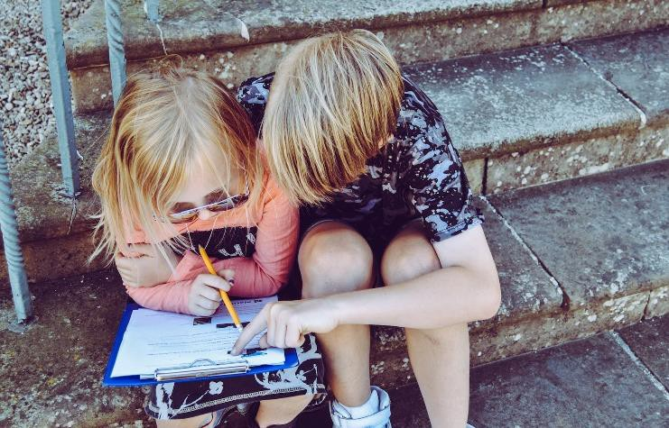
taught and is changing how they’re assessed. Parents and caregivers expect their child to learn the basics at school – reading, writing, and math. In the redesigned curriculum, these subjects remain important, but they aren’t the only vital part of students’ learning.
BC’s curriculum will continue to give your child a strong foundation in these important skills. It will also teach your child how to think, communicate, solve problems, and use their knowledge in ways that both matter in school and will matter in a rapidly changing future.

Teaching and learning
Today’s classroom is different from when you were in school. You may remember working only from textbooks or worksheets. Students now learn in many ways, often through experiences both inside and outside the classroom. They also show their learning in a variety of ways.

To support their learning, teachers create lessons that allow students to explore topics and learn important content.
Your child’s teacher may then observe students and have conversations with them about what they learned and how they might apply their learning. The teacher will use all the information they have gathered, including the work your child hands in, to assess your child’s learning. They will also determine where your child will go next in their learning or where they may need to improve.

Areas of learning
The areas of learning are the subjects your child will be taught from Kindergarten through Grade 12. These include English Language Arts, Français langue premiere, or Français langue seconde, as well as:

- Applied Design, Skills, and Technologies (shop, foods, accounting, computer programming, etc.)
- Arts Education (dance, drama, music, art, etc.)
- Career Education
- Languages (First Nations Languages’, French, and other
languages)
- Math
- Physical and Health Education
- Science (life science, environmental science, physics, etc.)
- Social Studies (BC First Peoples, law, world history,
- Francophone history and culture, etc.)

All areas of learning are important for developing educated citizens. What your child is learning at a particular time will depend on the time of year and the schedule your child’s school uses.

Learning Standards
Each area of learning has learning standards that lay out what your child should know, be able to do, and understand. The learning standards are what your child is taught at each grade level and what they are assessed on for their report cards.

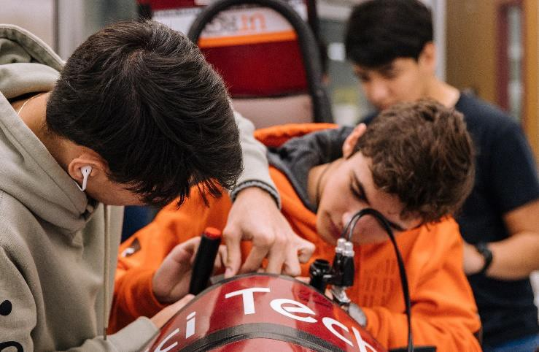

Core Competencies
The Core Competencies are integrated into all areas of learning. They are the communication, thinking, and social skills your child needs to be successful now and in the future.

Students are not assessed by teachers on the Core Competencies. Instead, your child’s written report cards will include their self-reflections on the Core Competencies and their goal setting for learning.

Indigenous learning
From kindergarten to grade 12, your child will have opportunities to learn about the perspectives, histories, and contemporary contexts of First Nations in BC. Learning in this area will support lasting and meaningful reconciliation. Your child will also develop an understanding of First Nations, Metis, and Inuit cultures across Canada.
Contact us at: student.reporting@gov.bc.ca

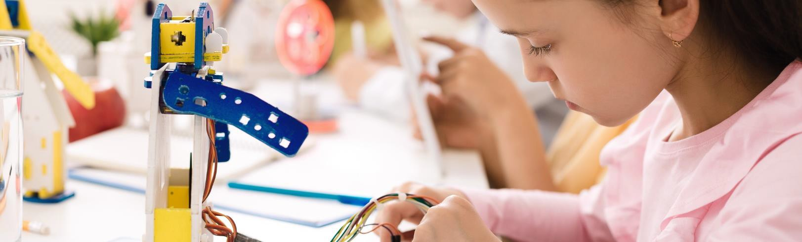

How will I know how my child is doing?

The way your child’s learning is shared with you is changing. This overview will tell you what you can expect from your child's report card, and from teacher updates.
What will my child’s
report card look like?
Each written update will include:
- information on how your child is doing in each area of learning
- written comments (descriptive
feedback) on your child’s strengths and areas they need to work on, as well as their work habits and behaviour
- information on the communication, thinking, and social skills that your child needs to be successful (Core Competencies) and your child’s goal setting
- information about your child’s
attendance
Note: For Grades 10-12, the last written update of the school year also tells you if your child is on track to graduate.

How often will I get updates from
my child’s teacher?
During the school year, you should expect to see 5 learning updates about your child. This will include 3 written learning updates (that could look like report cards), and 2 informal learning updates (could include conferences with a teacher, and phone calls or e-mails from a teacher).
Schools set the schedule for when learning
updates happen. However, your child’s teacher
may connect with you at any point.

If your child has an Individualized Education
Plan (IEP), you will receive learning updates in the same way as all the other parents and caregivers do. But your child may also get additional updates based on their IEP.

Your child’s marks (on the proficiency scale for Grades K- 9, and letter grades or percentages for Grades 10-12) are based on the learning they have shown in each subject.

Letter grades and percentages
If your child is in Grades 10-12, they will receive letter grades and percentages. Students currently require letter grades and percentages for the transition to post- secondary education.

The Provincial Proficiency Scale
If your child is in Grades K-9, you won’t see letter grades on their report card. Instead, you will see information on where your child is on the Provincial Proficiency Scale. The scale uses the terms “Emerging,” “Developing,” “Proficient,” and “Extending” to describe student learning. The scale maintains high standards for student learning.
Emerging | Developing | Proficient | Extending
Emerging means your child is beginning to understand something in an area of learning. They are still learning but may need more support to move ahead.  Emerging doesn’t mean your child in  unsuccessful in this area. | Developing means your child understands some things in an area of learning but still has other areas to work on. Like Emerging, it doesn’t mean your child is unsuccessful in this area. | Proficient is the goal for your child. It's also the goal for all students.  When your child is Proficient, it means they fully understand the required learning. But it doesn't mean their learning stops. | Extending is when students show a deeper understanding. It’s when your child is able to apply their learning in new and different ways.  Extending is not the goal for all students in every area of learning.

Descriptive feedback
You will receive written comments that clearly explain where your child is in their learning and any areas they need to work on. The comments will be short and easy to understand.

Work habits and behaviour
It’s important to note that grading and reporting are not disciplinary tools. Information on your child’s work habits and behaviour will be in the written comments on your child’s report card. Teachers should let you and your child know about any concerns before you receive a written report.

What information will I receive on Core Competencies and goal setting for my child?
Your child’s written reports will include their self- reflection on Core Competencies and their goal setting.

Self-reflection is when your child thinks deeply about the skills they have developed and how they can continue to grow those skills.

Your child will be reflecting on their communication, thinking, and social skills (Core Competencies).
When your child reflects on the competencies, they become actively engaged in their learning.

Your child will also be setting goals. As they set goals and work toward them, your child will be starting to shape their future. When they are faced with a problem, they will learn how to find creative solutions, instead of getting stuck.

Attendance
Your child’s written reports will include an attendance record. Attendance doesn’t affect your child’s marks, but it does impact their learning. Teachers should let you know about any concerns with your child’s attendance.

How will I know my child is on track to graduate?
If your child is in Grades 10-12, they will get a graduation status update in their last written report of the school year. This will ensure that your child and you have the information you need to plan for graduation and address any concerns early on.

What if my child has a disability or diverse ability?
Every student is unique and learns in their own way, which is why teachers work hard to make sure that each student can participate and contribute in all aspects of school life. Diverse and inclusive classrooms ensure each child is welcomed and supported in their learning, no matter their abilities. Classrooms are designed to be accessible to students so that your child can grow, learn and succeed.

If your child has specific learning needs and requires additional support, they will not be automatically given an Emerging, Developing, or lower letter grade on their report card. Their report card will include a mark based on the learning they have demonstrated and written comments on where they can go next in their learning.

Whether your child is an English Language Learner, a French language learner in a Francophone program, or has a disability or diverse ability, they will be supported every step of the way. At report card time, your child will receive their report card at the same time as their peers.

Can my child use tools and strategies to support their learning?
All students use tools and strategies to support their learning, not just students with an Individual Education Plan (IEP) or an Annual Instructional Plan (AIP). If your child uses a specific tool or strategy, like using speech-to-text or giving an oral presentation instead of taking a test, their marks will not be negatively impacted.

The types of support your child will receive depends on their needs and may not be noted on their report card. Instead, you will find this information in their IEP, AIP, and/or another school-created document.

What if my child is an English Language Learner?
If your child’s English language skills make it difficult for them to fully show their learning, they may not be given a mark. Instead, their report cards will have written comments describing what your child can do and areas they can work on while their English language skills are growing.

Once your child has English skills that allow them to show their learning, they will be given a Proficiency Scale indicator or letter grades and percentages on their report card.

What if my child is assessed only on their IEP goals?
In general, students are assessed on the Learning Standards of the curriculum. Most students with an IEP are assessed on the
Learning Standards. Very few students will be assessed on the goals outlined in their IEP instead of the Learning Standards. In these instances, there may still be some subjects, like art or gym class, where your child will still be assessed on the Learning Standards of the curriculum.

You should know that a mark may not be used when your child is being assessed only on their IEP goals. Their report card will still include descriptive feedback describing what your child can do and the areas they are still working on.

Contact us at: student.reporting@gov.bc.ca

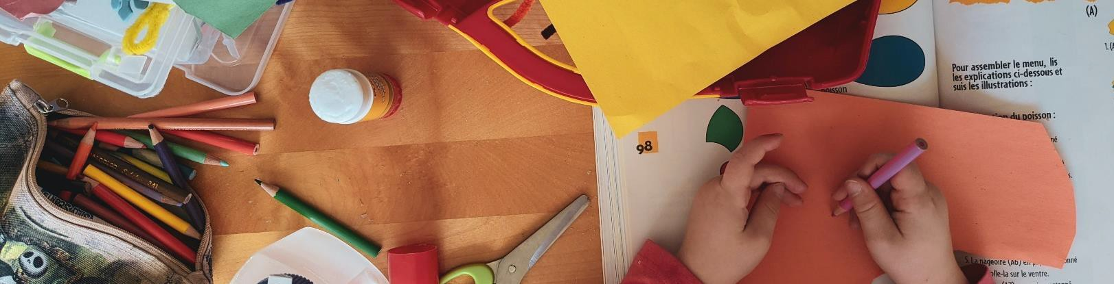
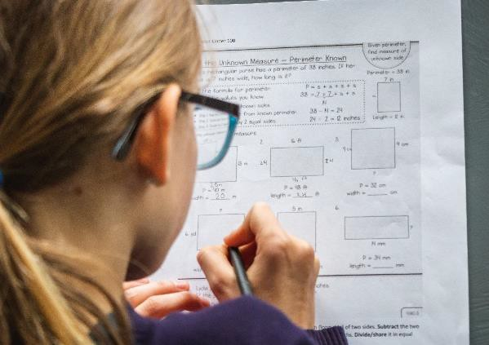

Why is my child not getting letter grades?

Provincial Proficiency Scale?
In grades K-9 the proficiency scale:
- maintains high standards
- makes learning the focus
- shows you where your child is at
- lets you know what your child still needs to work on
- helps students continue their learning, even after assignments are returned and report cards are received
- has a place for all learners
Why move to the
When you were in school and the teacher returned a test or assignment, chances are that everyone in the class rushed to compare their marks. The marks encouraged comparison instead of focusing on what students were learning.
If your child is in Grades K-9, you won’t see letter grades on their report card. Instead, you will see information on where your child is on the Provincial Proficiency Scale. The proficiency scale makes learning the focus rather than the comparison with others.
The proficiency scale lets you know where your child is in their learning, and what they need to work on. Along with the information provided by the proficiency scale, you will receive written comments from your child’s teacher to give you even more information about what your child can work on.
If your child is in Grades 10-12, you will continue to see letter grades and percentages. You will also see written comments because descriptive feedback will now be part of all report cards in Grades K-12.

The Provincial Proficiency Scale
Emerging | Developing | Proficient | Extending

What does the scale tell me about my child’s learning?
Students come to school knowing different things. And
the things they know shape what they learn next.

Your child will likely be Emerging or Developing at different times in the school year and in different areas of learning. But they will not always start at Emerging or Developing at the beginning of the school year. And it won’t just be at the end of the school year that they get to Proficient.

Proficient does not mean learning stops. If a child starts with Proficient understanding or gets to Proficient during the school year, the goal for them is to further their learning.
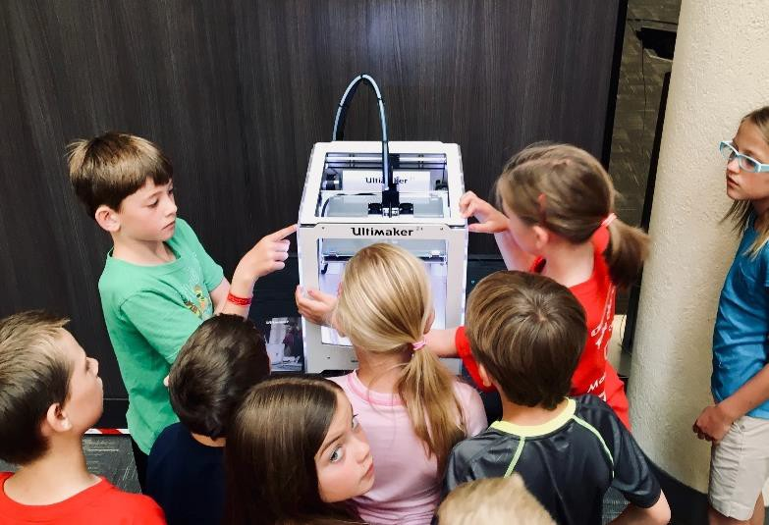

Emerging
Emerging doesn’t mean your child is not successful in an area of learning. It means they are beginning to understand something. They are still learning but may need more support to move ahead.

Developing
Like Emerging, Developing doesn’t mean that your child is not successful in an area of learning. It means they understand some things but still have other areas to work on.

Proficient
Proficient is the goal for your child. It's also the goal for all students. When your child is Proficient, it means they fully understand the required learning. But it doesn't mean their learning stops.

Extending
Extending is when your child shows a deeper understanding and is able to apply their learning in new and different ways. Extending is not the goal for all students in every area of learning.

Contact us at: student.reporting@gov.bc.ca

What is descriptive feedback?

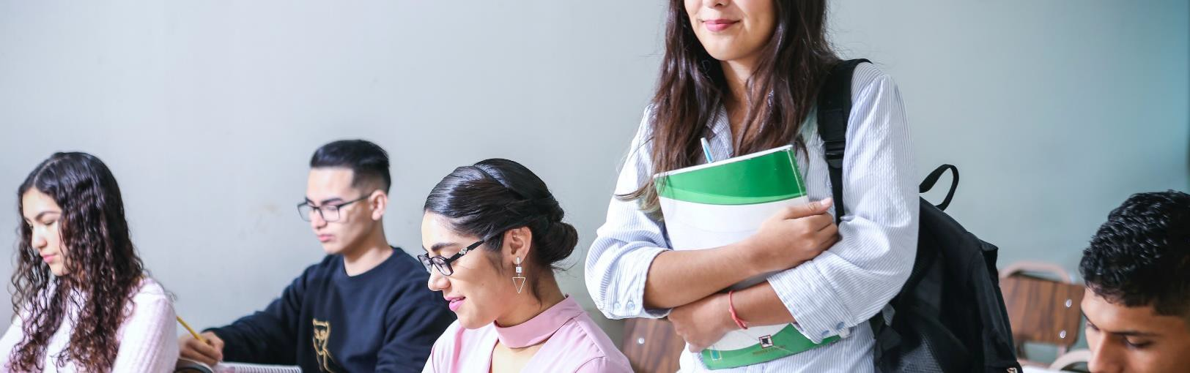
Descriptive
feedback:
- tells you what your child can do
- tells you what your child needs to work on
- tells you how your child interacts in the classroom
- provides strategies to help your
child further their learning
Why is descriptive
so valuable?
Descriptive feedback is the written comments
you will see on your child’s report card. Descriptive feedback is valuable for all students in all grades, from Kindergarten to Grade 12.
feedback from teachers
In Grades K- 9, your child may get a “Proficient” in math and a “Developing” in English. At first glance, you might assume that your child is “good” at math and “bad” at English. But this isn’t the case. All students have both strengths and areas they are still working on.
In Grades 10-12, letter grades and percentages alone won’t provide the whole picture of who they are as a learner. This is where descriptive feedback comes in. Teachers will give you written feedback that clearly explains what your child can do. It will also tell you what your child needs to work on to move forward in their learning.

Information about what your child can do
Learning happens at different speeds for different students. Your child's report card will clearly explain to you what your child can do and what they need to work on in each of their areas of learning. Descriptive feedback is the short, written comments from the teacher that explain your child’s current learning strengths and classroom behaviour.

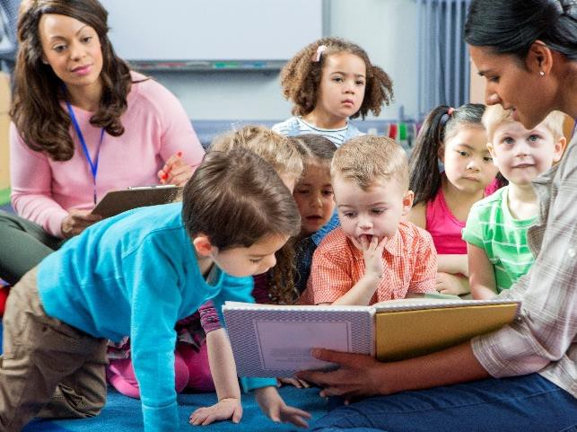

Information about your child’s work habits and behaviour
Your child’s marks (on the proficiency scale, or letter grades and percentages) reflect their learning in each area. The written comments include information on your child’s work habits and behaviours.

Grading and reporting are not disciplinary tools. For example, students can’t lose 10% of their grade for not bringing gym clothes to class, and they can’t have marks taken away as a punishment for being late.

But behaviour in school is still important. If a student does not attend or participate in class, it will be difficult for teachers to assess their learning.

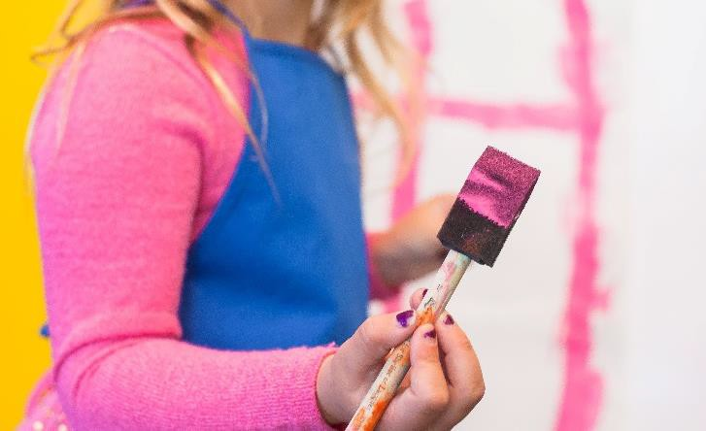

Information about what your child needs to work on
The information in your child’s report card shouldn’t come as a surprise. Ideally, before you receive a report card, you should hear from your child’s teacher about any areas that need to improve, whether in their learning or their behaviour

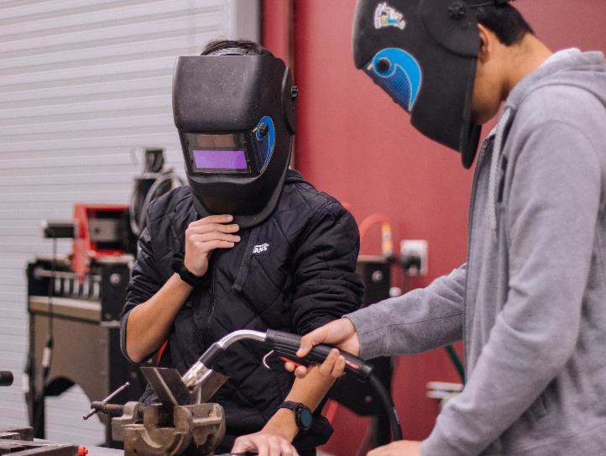
But the report card will also provide written information about what your child can do and areas they need to work on. The teacher may describe ways that you can support your child at home. They may also explain how your child is being supported in class to improve and move forward in their learning.

Contact us at: student.reporting@gov.bc.ca

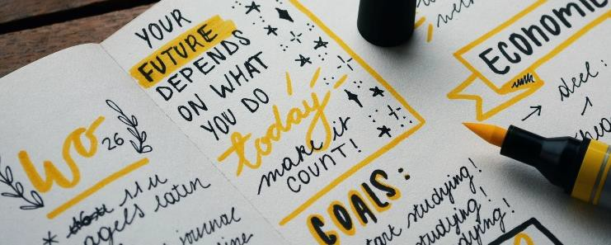

Why is my child self-reflecting and setting goals?

How can self-reflection and goal-setting help students?
Self-reflection and goal setting:
- actively involves your child in their learning from Kindergarten through Grade 12
- helps your child understand their
strengths and challenges
- teaches your child how to set goals and work toward them
- develops the skills your child will need to be successful in school and in the future
Our world is constantly changing. It’s still important for students to learn facts and information, but it’s also important for students to learn how to think, communicate, and interact with others. This is where the Core Competencies come in. The Core Competencies are part of BC’s curriculum, so every day your child goes to school, they will be building these skills.
Self-reflection and goal setting are important life skills for students to learn from the earliest age. These skills will help them succeed both in school and in their future, including in the workplace. Self-reflection and goal setting will help your child understand themselves better, work toward and meet their goals, and celebrate their successes.

What are the Core Competencies?
The Core Competencies (Communication, Thinking, and Personal and Social) are part of the BC curriculum. Learning these skills sets students up for success in school, in the workplace, and in their relationships with others.

Like you, your child's teacher is helping your child build these skills every day. This is how your child will learn how to have healthy friendships, care about others, communicate well with others, think critically, and solve problems.

What will you see on the report card?
Self-reflection on the Core Competencies and the goal-setting process are meant to be meaningful for your child. The ministry doesn’t require a specific format for all students in the province. This could be a written response, an art project, an audio or video recording, a portfolio entry, or something else. Your child's school will decide what makes the most sense for all students in the school.

On each written report that you receive, your child’s teacher will tell you where you can find your child's reflections and goals.

What is self-reflection and goal setting?
Your child will be reflecting on their communication, thinking, and social skills (Core Competencies). Self-reflection is when your child thinks deeply about the skills they have developed, and how they can continue to grow those skills.

Your child will also be setting goals. Goal setting is deciding on a learning target and then working toward it. As your child sets goals and works toward them, they are shaping their future. When they have a problem, they will learn how to find creative solutions instead of getting stuck.

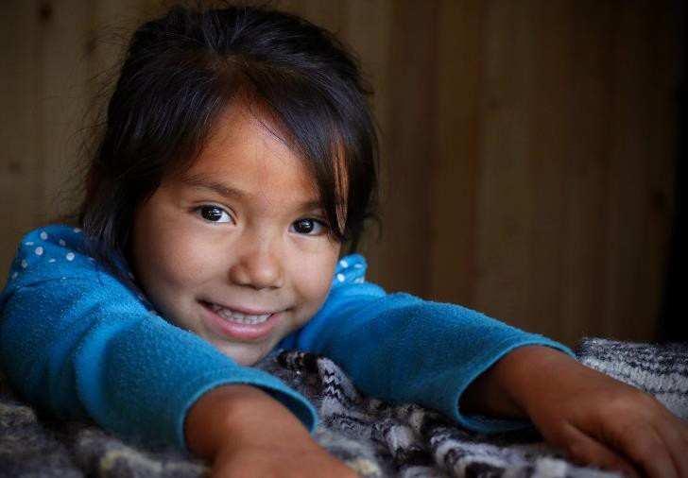
Research shows that students do better when they have a say in their learning. Self-reflection and goal setting gives them that chance.

Contact us at: student.reporting@gov.bc.ca

How will I know my child is on track to graduate?

Why a Graduation Status Update?
Status Update:
- tells you and your child about the different pathways to graduation in BC
- shows your child’s progress in completing all the courses and assessments they need to graduate
- helps your child select courses
- makes you and your child know earlier about any possible problems with graduation
The Graduation
Do you know what courses your child needs in order to graduate? The graduation status update clearly states which graduation path your child is on and gives you information about that pathway.
When your child is in Grades 10-12, they will receive a graduation status update in their report card each June. The graduation status update provides a snapshot of your child’s progress in completing the courses and assessments they need for graduation. It will show you which courses and assessments have been completed, which courses your child is currently enrolled in, and what still needs to be done in order for them to graduate.
The graduation status update will also help your child with course selection. It makes sure everyone is aware of any problems with
graduation before it’s too late.

Did you know there are a few different ways to graduate in BC? Different graduation pathways have different course requirements. There are also different provincial assessments students will need to take.

Dogwood Diploma
British Columbia Certificate of Graduation (Dogwood Diploma). To graduate with a Dogwood Diploma, students must earn a minimum of 80 course credits in Grades 10, 11, and 12, and take one provincial assessment in numeracy and two in literacy.

Dual Dogwood
Students in a Francophone school or in French Immersion programs in BC can earn two certificates: one in French (Diplôme de fin d'études secondaires en Colombie-Britannique) and one in English (Dogwood Diploma). To earn both certificates, students must:
- meet all the graduation requirements for the Dogwood Diploma
- take additional Francophone or French Immersion courses in each of Grades 10, 11, and 12
- earn at least 12 more credits toward graduation in courses that are taught in French
- take provincial assessments in numeracy and literacy
that are specific to their program

Adult
Graduation Diploma

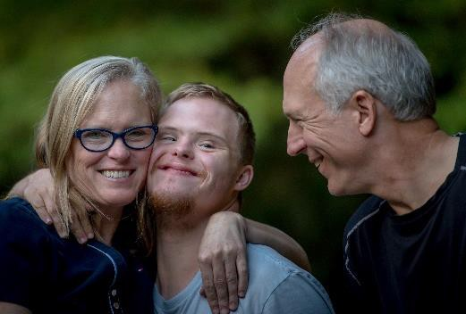

Evergreen Certificate
The School Completion Certificate (Evergreen Certificate) is a recognition and celebration of successful learning, but it is not a graduation diploma. It's important that students and their parents or caregivers understand that the Evergreen represents the completion of personal learning goals but does not represent graduation. They also need to understand the impact this decision could have on a student’s future.
The decision to put a child on an Evergreen pathway should not be made before Grade 10 and should include the student’s parent or caregiver’s informed consent.

BC offers an alternative pathway for adults seeking to obtain their Diploma. The British Columbia Adult Graduation Diploma (BCAGD) requires 20 credits of study instead of the 80 credits required for the Dogwood Diploma. Students must be at least 18 years old to enter the Adult Graduation Program.

If a school-aged student (aged 18 or 19) is contemplating switching from the BC Graduation Program to the Adult Graduation Program, the school must ensure the student and their parent or caregiver are fully informed of the implications and potential limitations of the BCAGD, including the differences between the Dogwood and the Adult Dogwood credentials and the prerequisites needed for post-secondary.

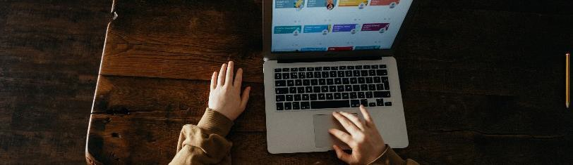

Provincial Assessments
A student's graduation requirement will include taking 3 provincial assessments in literacy and numeracy and may include additional assessments in French for the Dual Dogwood. The specific assessments they need to take will be listed on their Graduation Status Update.
Students in the Adult Graduation Diploma or Evergreen programs do not need to take these assessments.
Contact us at: student.reporting@gov.bc.ca

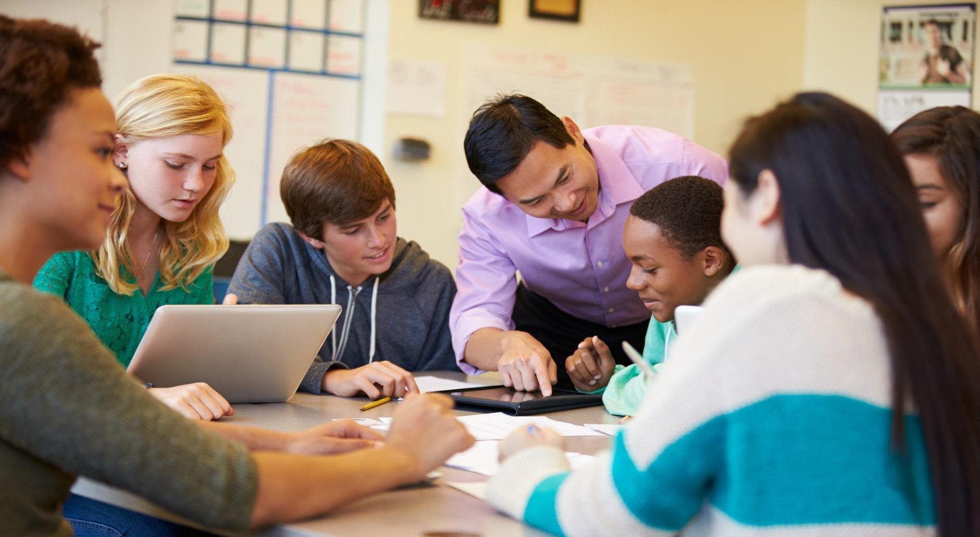
Additional Information

We understand that after reading this booklet you may still have questions.

If you have questions about the changes coming to student reporting in BC, please reach out to the ministry via email at student.reporting@gov.bc.ca.

For more specific questions about report cards, you can connect with your child’s teacher, principal, or school district staff. They will be able to provide you with information about what reporting looks like in your child’s school or school district.

You can also find more information about student learning on the following web pages:

- BC’s Curriculum - https://curriculum.gov.bc.ca/

- Core Competencies - https://curriculum.gov.bc.ca/competencies

- Graduation Program Handbook - https://www2.gov.bc.ca/assets/gov/education/administration/kindergarten-to-grade- 12/graduation/handbook_of_procedures.pdf

- Indigenous-Focused Graduation Requirement - https://www2.gov.bc.ca/gov/content/education- training/k-12/support/indigenous-focused-graduation-requirements

- Provincial assessments - https://curriculum.gov.bc.ca/provincial/assessment

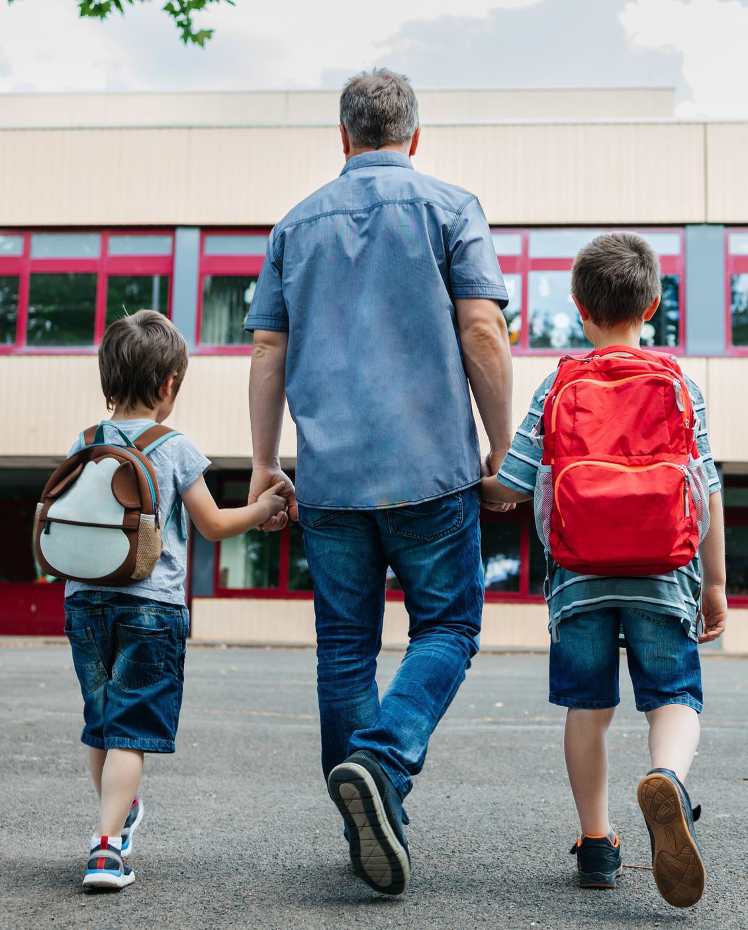
Email
student.reporting@gov.bc.ca
Website
https://curriculum.gov.bc.ca/

